28. Create client library in AEM (client library part 2)

**Creating client libraries**

Right click on the page that we created earlier. In this case, it’s “training”.

Create -> Create Node -> Provide name of the clientlib and type should be **“cq:ClientLibraryFolder”**

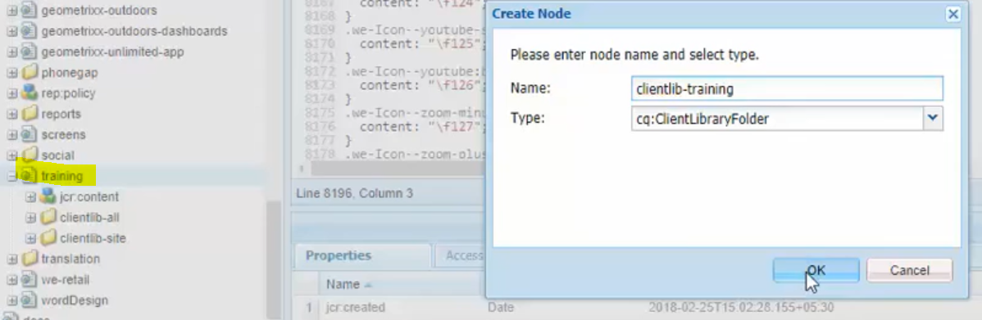

Once the client library is created, create js and css folders inside it. Create js.txt and css.txt files as well.

js.txt - for mentioning all the list of js files to be loaded

css.txt - for mentioning all the list of CSS files to be loaded

ex:

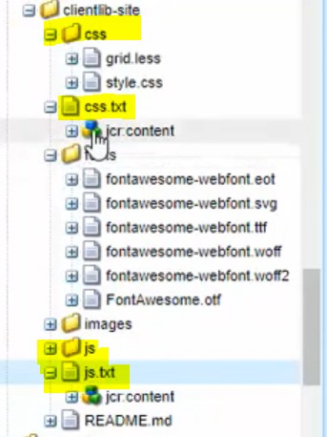

js.txt

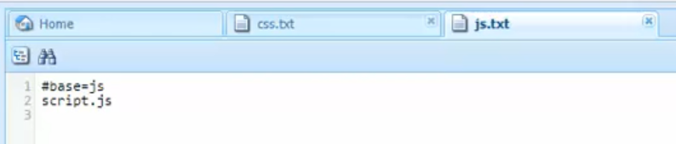

#base – for mentioning the root folder location.